Oyster Task Force Meeting
Tuesday, April 11, 2023, 1:00pm
New Orleans Lakefront Airport
6001 Stars and Stripes Blvd.
New Orleans, LA

I. Pledge of Allegiance
II. Roll call and introduction of guests
Voting Members Present:
Jakov Jurisic
Mitch Jurisich
Brad Robin
Brandt Lafrance
Al Sunseri
Willie Daisy
Steve Pollock
Sam Slavich
Peter Vujnovich

Voting Members Absent:
Shane Bagala
Tracy Collins
Dan Coulon
Brandon Debarge
Matthew Slavich

Non-Voting Members Present:
Carolina Bourque
Edward Skena
Sarah Roy
Brian Lezina
Jennifer Armentor in for Justin Gremillion

Non-Voting Members Absent:
Harry Vorhoff

III. Peter Vujnovich motioned to approve the March 14, 2023 meeting minutes, 2nd by Brad Robin. Motion carries.
Brad Robin motioned to amend the agenda by moving item F under New Business to item A., 2nd by Peter Vujnovich. Motion carries.
Brad Robin motioned to approve the agenda as amended, 2nd by Peter Vujnovich. Motion carries.
IV. Treasury Report
Remaining Fund Balance- $570,786
Remaining Budget Balance- $14,980
March oyster tag sales- 274,800
Peter Vujnovich motioned to approve the treasury report as presented, 2nd by Brad Robin. Motion carries.
V. Committee Reports
- Public-Private Oyster Seed Grounds Committee-
The committee met today to discuss possible changes to the Oyster Lease Damage Evaluation Board, looking into the cost of harvesting a sack of oysters, Jack Isaacs working some of the numbers and will get back to the task force with more concrete estimates, hope to have something before the next meeting, seeking to nominate a new member to replace Matthew Slavich on the OLDEB

- Enforcement Report-
March 4th- March 30th

Region 4 (Iberia)
None

Region 5 (Calcasieu and Cameron)
None

Region 6: (Terrebonne, Lafourche, Grand Isle)
Terrebonne
1- Take commercial fish without vessel license in possession
1- No numbers on vessel

Seizures:
None

Region 8: (Jefferson, Plaquemines, St. Bernard, Orleans)
St. Bernard
1-Violate Sanitation Code (Log Book)
1-Intentional Concealment
1-Intentional Littering
1-Resisting an Officer
Seizures:
50 Full Sacks seized returned to waters

Steve Pollock requested that enforcement cite specific laws that deal with each violation- I.e.- title 40 and title 56
Mitch Jurisich stated that there have been issues with dual claimed land- complaint in region 6 office

Jakov Jurisic requested that Major Skena provide all relevant laws in Title 76 and Title 51, 56
Request from health to be provided a copy of all relevant laws to oysters in Title 51

Jennifer Armentor stated that LDH allows for corrected action from white to green tags. This is for dealers on land, LDWF enforcement regulates on water, can change from white to green tags on land but NOT green to white this is corrective action in the HAACP plan that the dealer can do
Edward Skena stated that the current law does not allow you to change the tag once you declare what you are fishing, there is currently no corrective action allowed on the water in this case; will need to discuss and look into for future legislation and changes

- Legislative Committee Report- no report
- Legal Committee Report- no report
- Research Committee Report- no report
- Coastal Restoration Report- no report
- Marketing Report- Anna Koehl stated that BMF has been meeting with the oyster industry getting initial testimonials, there is audio issues- currently researching other equipment options to work better in the field, will schedule more video testimonials

Jakov Jurisic stated that the SPMB did not meet since the last OTF meeting, currently requesting a summary of oyster efforts from the board, the task force thanked the SPMB for sponsoring the ISSC chairman’s reception, was a great event

- Health Committee Report- no report, no new cases
- Aquaculture Committee Report-
Steve Pollock stated that the committee hosted a meeting prior to the OTF meeting, the committee heard an update on CPRA funding for AOC- requested to develop communication between the industry and CPRA and program development; discussed movement of oysters from east coast to the GULF, requested that the OTF write a letter to the Hatchery Certification Board and to the Gulf States to express objection towards the movement of oysters from the east coast to the Gulf of Mexico, whether that be seed or adult oysters

Steve Pollock motioned to write a letter of objection to the Hatchery Certification Board and the Gulf States Marine Fisheries Commission, Molluscan Shellfish Subcommittee on the movement of oysters of any size from the east coast to the Gulf of Mexico, 2nd by Jakov Jurisic. Motion carries.

The committee also discussed the max seed size to be grown in prohibited waters, there is currently a 1” max size, do not wish to see the size increased or decreased;

Mitch Jurisich motioned to address the seed size situation if/ when it arises, 2nd by Steve Pollock. Motion carries.

Plan to host an OTF joint committee meeting- Aquaculture, Enforcement, and LDH to discuss AOC regulations in the future

- Joint Task Force Working Group Report- no report
VI. New Business
- The task force heard a presentation and considered funding for an oyster industry marketing campaign with WWLTV and Tegna
Sandy Garcia provided the task force with a presentation on the metrics and outcome of the 2022 campaign, which ran from August 26th- October 31st.
Across our platform of Broadcast stations:
- 632 Commercials Ran
This reached 96.9% of all households 35+ and 92.5% of all households18+
- 5,436,000 gross household impressions were delivered to Adults 35+ (6,108,000 A18+)
- 8.3 Household frequency
643,055 Net Reach (1,215,759 A18+)

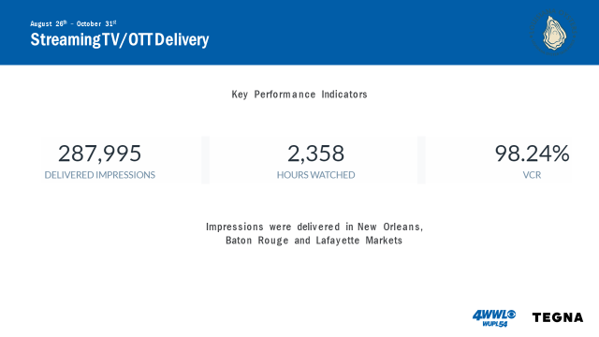
New Campaign Proposal:
: 30 customized video production using footage from previous spot focusing on oysters and Louisiana seafood being a vital part of the current waterways *Raw footage remains the property of WWL

Investment: .30 spot: $35,000

Task Force asked if there could be a link or QR code to their website; looking to do this new fiscal year in July 2023
Jakov Jurisic motioned to dedicate $35,000, starting on July 1, 2023, for a marketing campaign with WWLTV and Tegna, 2nd by Brad Robin. Motion carries.
- The board heard discussion on possible changes and propose nominations for the OTF seat on the Damage Evaluation Board
Jakov Jurisic motioned to nominate Sam Slavich to replace Matthew Slavich as the Oyster Task Force representative on the Oyster Lease Damage Evaluation Board, 2nd by Brad Robin. Motion carries.
Jakov Jurisic moved to close nominations, 2nd by Brad Robin. Motion carries.
- Beth Stauffer, ULL provided a presentation and update on the Lo-Spat Oyster Project
www.Lospat.org; resources- to view the real time data
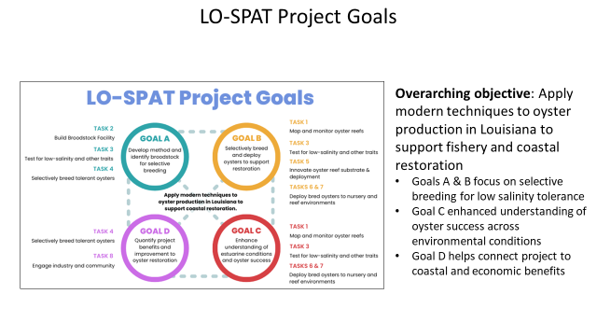

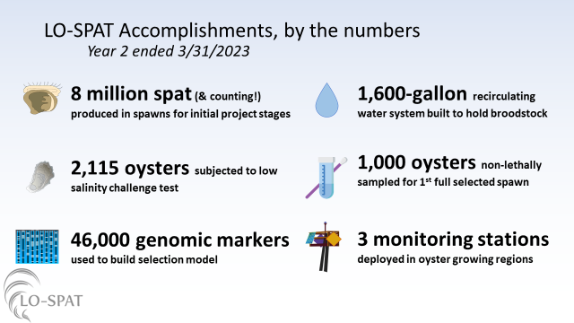
Jakov Jurisic asked if these changes would change the texture of the meat? Beth Stauffer responded stating that they have not looked into this as of yet and do not have the data but this has been talked about
- Jakov Jurisic provided an update on the Interstate Shellfish Sanitation Conference
Jakov Jurisic stated that LDH would not supply documentation stating that they could not release the information to a private entity, was not provided necessary documentation- model ordinance, was unprepared for what the task force was about to face, lack of preparation, issue came before task force 2, went in favor of the task force, the chairperson provided extra time, ultimately it passed, there was a lady from Alaska trying to help the OTF pass the issue, motion was made to send the issue to the committee on Time and Temperature- would meet in 2 years, made a request for a motion to reconsider and it was voted on, committee on Foreign Relation did not have an agenda, during the debate Justin Gremillion made some positive comments to help, ultimately it was passed- “No adverse public health significance. Gulf States have had no significant historical bacterial based risk during cold-water months Dec-Feb. This will allow states the option to have the harvest time to temperature controls based on Average Monthly Maximum water temperature instead of only Average Monthly Maximum Air Temperature, (as it was prior to 2012)”
Al Sunseri stated that this conference has been different than he has seen in 30 years, FDA was willing to work with the industry again as they used to,
- Task force postponed item E. To Discuss LDH Oyster Processing Regulations and Recent Changes to a future meeting
- The task force heard an update on legislation (HB 438) regarding the oyster vessel permit
Representative Owen, from St. Tammany, filed the bill
Mitch Jurisich asked the task force to stay on top of this; plans keep the board updated on this; assigned to House Committee of Natural Resources but date of hearing should be published soon
Al Sunseri stated that the WLF Commission supported the bill last week at their meeting, should be easy to pass
VII. Public Comment
Mitch Jurisich thanked Carolina Bourque for all of her help over the years and hope to stay in touch after her departure from her position at LDWF as the OTF biologist representative, Carolina will remaining working at LDWF.
Brad Robin stated that the industry has accomplished a lot, wished Carolina the best in her future endeavors
VIII. The next meeting set for Tuesday, May 9, 2023 for 10am at the New Orleans Lakefront Airport
IX. Brad Robin motion to adjourn the meeting, 2nd by Peter Vujnovich. Motion carries.

